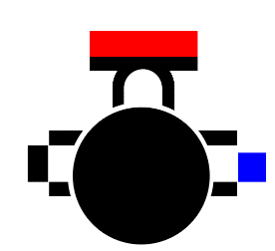Hull Pixelbot Parts List

|  |  |
| --- | --- |
| M3 6mm buttonhead bolt | 6 |
| M3 10mm buttonhead bolt | 26 |
| M3 16mm buttonhead bolt | 0 |
| M3 10mm countersunk bolt | 2 |
| M3 nut | 24 |
|  |  |
| Robot Top | 1 |
| Robot Base | 1 |
| Robot wheel hub | 2 |
| Robot Wheel | 2 |
| Robot Bumper | 2 |
| Robot Side | 2 |
| Spacer washers | 8 |
| Power switch holder | 1 |
|  |  |
| Stepper Driver Board | 2 |
| Stepper Motor | 2 |
|  |  |
|  |  |
|  |  |
| Cable MM 20cm black | 1 |
| Cable MM 20cm red | 1 |
|  |  |
| Cable FF 20cm black | 1 |
| Cable FF 20cm red | 1 |
|  |  |
| Cable MF 20cm green,yellow, orange,red | 1 |
| Cable MF 20cm white, grey, purple, blue | 1 |
| Cable MF 20cm yellow, orange, red, brown | 1 |
|  |  |
| Rocker switch | 1 |
| Arduino Uno | 1 |
| Battery holder | 1 |
| AA Batteries | 5 |
|  |  |
| HC-SR04 Distance sensor | 1 |

Version 1.0 Feb. 2018  
Rob Miles